Workshop1 Handout

Creating Job Portal APIs with AutoMapper, Domain-Driven Structure, Repository Pattern, and JWT Authentication

Overview

Welcome to the workshop on creating a Job Portal API using AutoMapper, Domain-Driven Structure, Repository Pattern, and JWT Authentication. In this workshop, you will learn how to build a robust and scalable API for a job portal application. The workshop will cover topics such as authentication, CRUD operations, DTOs, and repository pattern implementation.

Workshop Goals

1. Understand the basics of creating a Web API using ASP.NET Core.

2. Implement JWT authentication for secure API access.

3. Utilize AutoMapper for mapping between entities and DTOs.

4. Implement a repository pattern for data access.

5. Develop API endpoints for managing job seekers, companies, skills, and locations.

Prerequisites

1. Basic understanding of C# and ASP.NET Core.

2. Familiarity with Entity Framework and Repository Pattern.

3. Visual Studio installed on your machine.

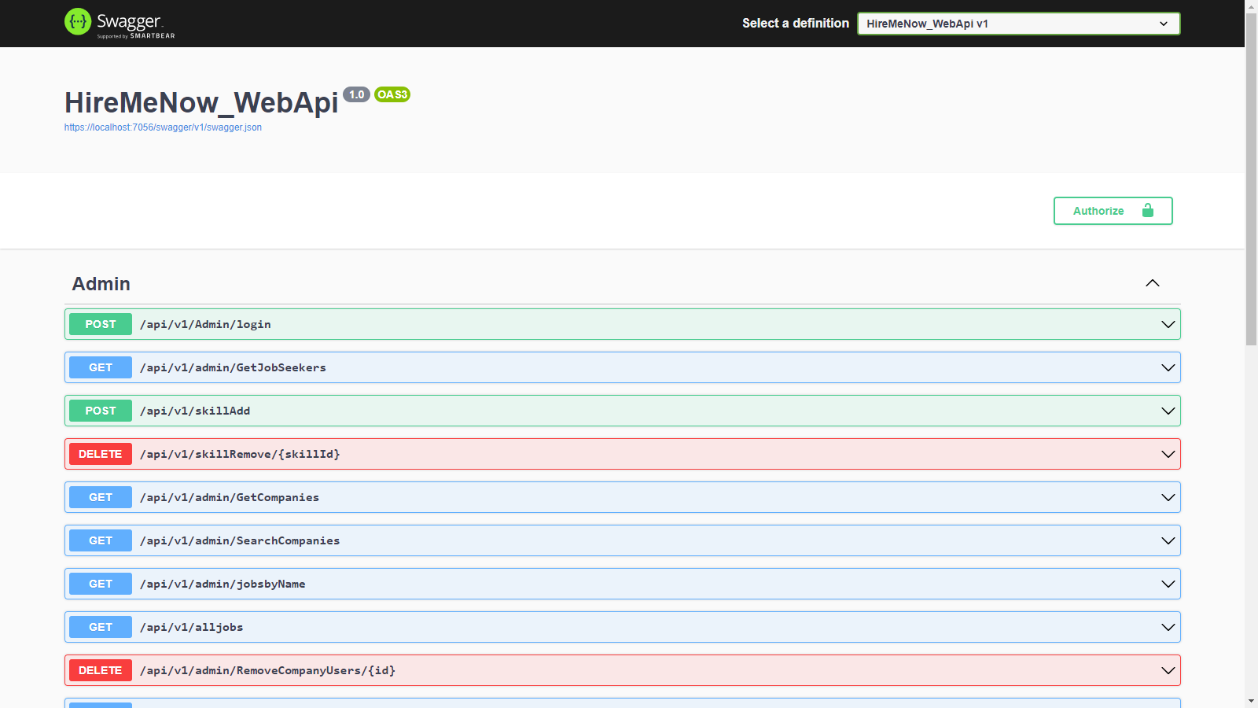

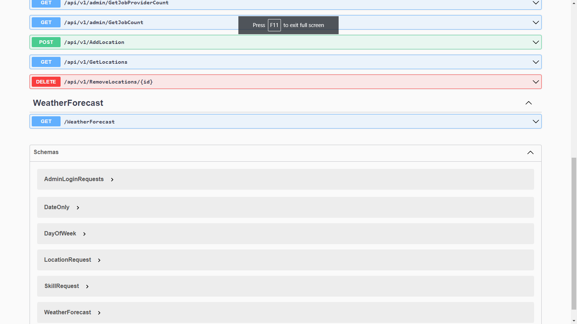

Workshop Agenda

Session 1: Introduction to the Project Structure

- Overview of the project structure following Domain-Driven Design principles.

- Explanation of the repository pattern and how it is implemented in the project.

Session 2: JWT Authentication Implementation

- Explanation of JWT authentication and its advantages.

- Walkthrough of how JWT authentication is implemented in the project.

Session 3: AutoMapper Setup and Usage

- Introduction to AutoMapper and its benefits.

- Demonstration of how AutoMapper is configured and used in the project.

Session 4: Creating API Endpoints

4.1 Job Seekers Management

- Implementing endpoints for retrieving job seekers.

- Adding skills to a job seeker.

- Removing skills from a job seeker.

4.2 Companies Management

- Implementing endpoints for retrieving companies.

- Searching for companies by name.

- Deleting a company and its users.

4.3 Jobs Management

- Implementing endpoints for retrieving jobs.

- Searching for jobs by title.

- Retrieving all jobs.

4.4 Locations Management

- Implementing endpoints for adding, retrieving, and deleting locations.

Session 5: Testing and Troubleshooting

- Testing API endpoints using tools like Postman.

- Troubleshooting common issues in API development.]

Conclusion

By the end of this workshop, you should have a solid understanding of building a Job Portal API using ASP.NET Core, AutoMapper, Domain-Driven Design principles, and JWT authentication. Feel free to explore the provided resources and experiment with the code on your own. If you have any questions, don't hesitate to ask the workshop facilitators. Happy coding!